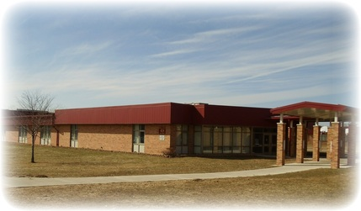 |  | Potterville Middle School  - January 2015

Preparing Students to be the best

- Trooper Marco Jones of the Michigan State Police visited the middle school last month. He spoke to students at two separate assemblies about anti-bullying and the importance respectful behaviors in the middle school.
- Mr. Vedder’s Viking Vision Advisory class, comprised of 7th and 8th grade students, has been bringing the anti-bully message to the younger grades. This week they presented anti-bullying messages to 5th and 6th grade classrooms.
- The School Improvement Team has been meeting and training in preparation for the introduction of PBIS at the Middle School. The staff is excited about the full implementation of PBIS in fall 2015. https://www.pbis.org/school
- There are a record number of students who applied and were awarded “gold level” at the Middle School. Gold level students are given extra privileges in school beyond what the normal students are allowed.
- The 6th graders will be spending a week in March at Potter Park Zoo, using the zoo as the classroom. To help offset the cost of this trip, we are doing a fundraiser at Buffalo Wild Wings. Bring the school provided flier to Buffalo Wild Wings, 20% of your purchases will go to our cause. We plan on distributing the flier to as many students as possible. We would greatly appreciate your support for this awesome opportunity for our students!
- Students are getting involved with clubs and activities. Science Olympiad, Girl’s Circle, and Student Council.

Events and Happenings

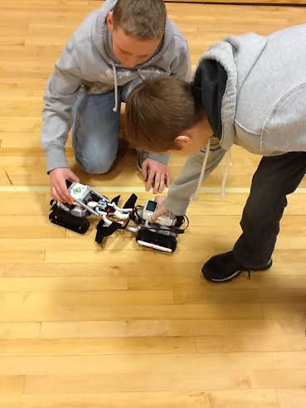
Robotics students Ethan and Mitchel test out their robot designs using LEGO EV3 Robots.

Assessments | Curriculum | Viking Vision
Middle School teachers are continually gathering information concerning the achievement and learning of our students. Some of the latest figures show that students are improving in math and reading. 5th grade math fluency and understanding of basic math facts has improved from 20% fluency when the year began to 75% this week according to the Reflex Fluency Growth Report. According to the Scholastic Reading Inventory, which measures student reading proficiency, the Middle School has made progress toward students being classified as proficient readers. | Potterville Middle School has adopted the Engage NY curriculum for 5th – 8th grade Math and for 7th and 8th grade English Language Arts (ELA). The Engage NY Curriculum challenges students to collaborate and think critically, preparing them for the jobs of tomorrow. In addition, Engage NY aligns to the Common Core State Curriculum.  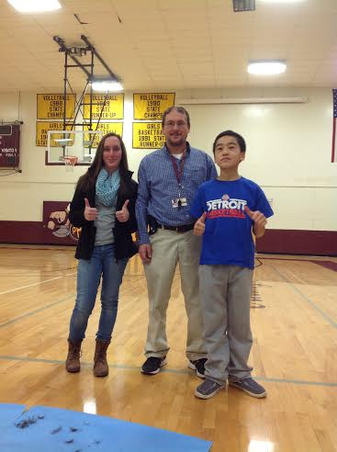  This year, the middle school was able to add Robotics as an elective to the schedule. Robotics allows students to learn Science, Technology, Engineering, and Math (STEM). In addition, the class teachers problem solving and collaborative teamwork.  Mr. G’s new haircut, curtesy of the 7th and 8th grade students of the month. | The first year of Viking Vision (VV) Advisory Period at the Middle School has shown positive results. The advisory period, designed to build community, support interventions, and benefit reading and health, is a 25 minute period of the day in which students meet to work on various activities.  VV classes have worked to improve the school and the community through service projects as well as getting to know fellow teachers and staff better. The current schedule for the VV week is:  Monday: Class Reading Book  Tuesday: Interventions  Wednesday: Community Building  Thursday: Interventions  Friday: Movement Day

Potterville 6th Grade
A great cause
and some great food
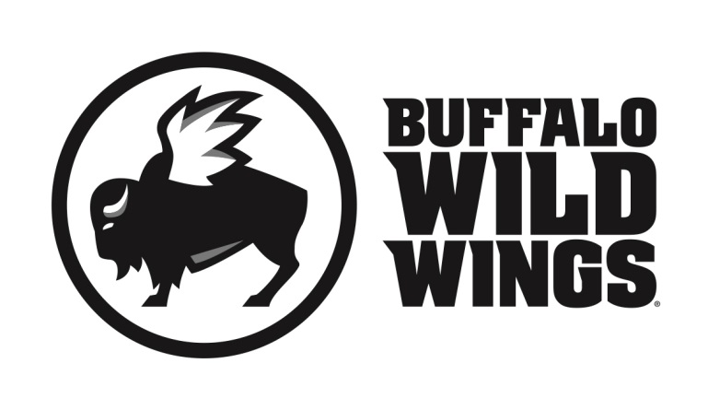

All friends, family and supporters of Potterville 6th Grade
are invited to participate in their fundraising event on
Wednesday, February 4, 2015
Everyone is invited to gather at Buffalo Wild Wings in Lansing (718 Delta Commerce Dr.) for lunch, dinner, or a snack. On this day, 20% of purchases* accompanied by the certificate below
will be donated to the
Potterville 6th Grade
Potterville 6th Grade
Wednesday, February 4, 2015

Present this certificate to your server at the
time of your order and 20% of your
purchases* will go to support the
Potterville 6th Grade

Only valid at 718 Delta Commerce Dr., Lansing, MI (517) 886 - 9464
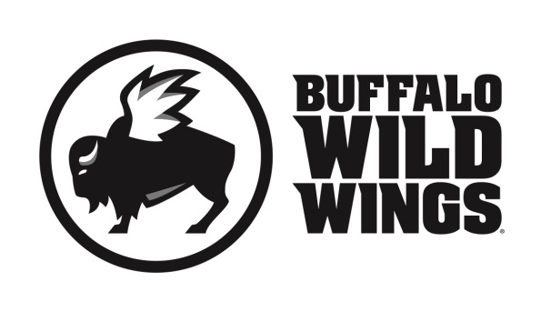

*Valid towards Dine-In and Carry-Out. Not valid towards gift card purchases. Flyers are not permitted to be distributed inside or outside the restaurant.

